**Continuing the Setup**

**Matthew Dias**

Throughout the lab I will be going over setting up new programs on your Servers. We will be installing Tmux, emacs, and Fail2Ban. Along with cowsay and lolcat just for fun!

**Finding Repositories in CentOS**

You can use are **yum repolist** to list all the repositories that are currently installed on the server. You could also use **yum repolist all** to view all the installed repositories, even ones that are currently disabled.

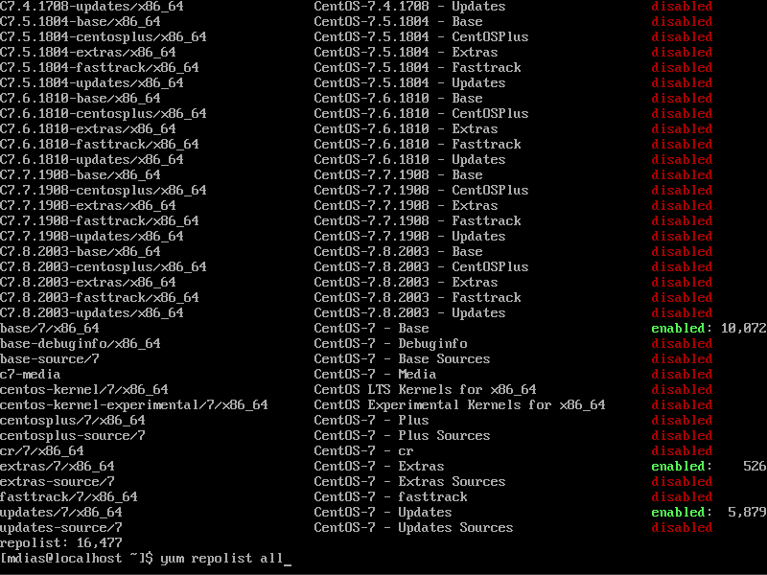

**Adding New Repositories and enabling them in CentOS**

To add a repository use: **yum-config-manager –add-repo (url for the repository)**

To then enable it use: **yum-config-manager –enable (repository)**

**Adding PPA**

Adding the PPA repository to the list: **sudo add-apt-repository <PPA_info>**

Update the list of packages that can be installed: **sudo apt-get update**

Install the package: **sudo apt-get install <package_in_PPA>**

**Finding Repositories in Ubuntu**

You can find repositories in Ubuntu by going to the folder /etc/apt and they’re under sources.list. If you’re having trouble seeing these options I had to enter root but typing in sudo su. After this I was able to make my way to the sources.list. To view that inside sources.list you can just simply cat the file using cat source.list. A black background with white text

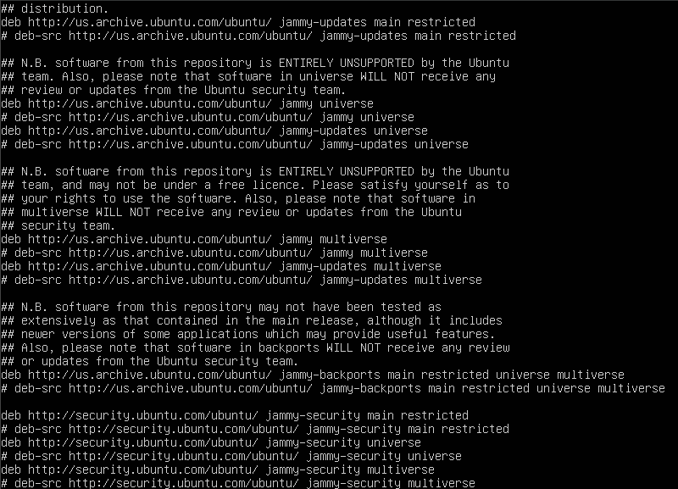

**Ubuntu Install Tmux: 05/02/2024**

What is Tmux? Tmux is a terminal multiplexer. This allows you to access and manage multiple terminals at the same time.

To install tmux onto our Ubuntu server we want to run the command sudo apt-get install tmux. You will next be prompted to type in your admin password, after doing do you will get the following results to know it was a success! You can see mine is saying I already had this installed so your results may be different.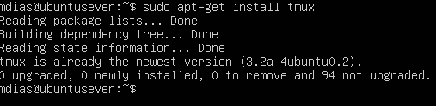

Since my results are different I want to show you how to verify that it is installed. You run the command tmux -V and that will give you the following results when it is installed to your server

Using tmux is easy! Simply type the command tmux to start the program. This will start the new window. You can use it however you need it to be used. You can see all I did was run ls in the new window. To exit the program you will do CTRL+B first then hit D.

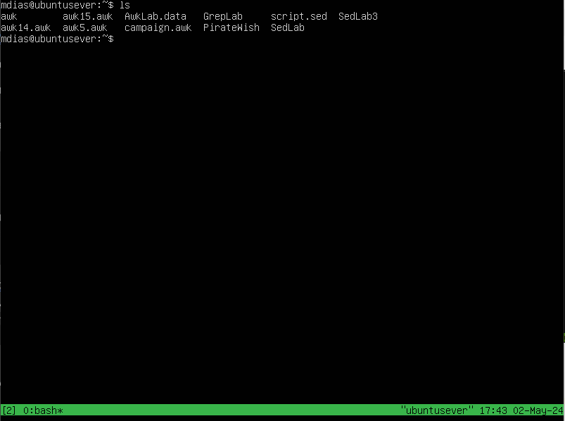

**Ubuntu Install emacs: 05/02/2024**

What is emacs? Emacs is a text editor that can be used for simply writing text files or going as far as writing code for Python, C, or Java.

Installing emacs will be very similar to our previous install. You will run the command sudo apt-get install emacs. After this command runs it will ask you to type either a y or n. You will type y to continue and this will finish this installation.

To verify emacs was successfully installed you can check by running the command emacs -version and you should see the following results

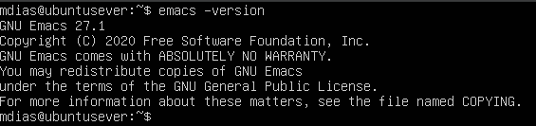

Now using emacs is a learning curve with a lot of options but I’m going to show you how to start it, make a new text file, write in it, save it, and exit the software. First run the command emacs and you’ll get the welcome screen. You will use the arrow keys to make your way down to “Visit New File” and hit enter.

It will be highlighted at the bottom of the screen. Type in a file name, I did text.txt and hit enter. You can now write whatever you’d like to be here. To exit you’re going to do CTRL + X then CTRL+C. You can see the options at the bottom. You can type y to save and exit. A computer screen shot of a black screen

**Ubuntu Install Fail2Ban: 05/02/2024**

What is Fail2Ban? Fail2Ban monitors your log files to help prevent any malicious brute force attacks on your server

Installing Fail2Ban on our server is done by running the command sudo apt-get install Fail2Ban. Once this command is running you will be ask to enter either Y or n, please enter to continue the installation.

To make sure fail2ban is running we want to run /etc/init.d/fail2ban start. Then we can check the status with /etc/init.d/fail2ban status. Both can be seen below!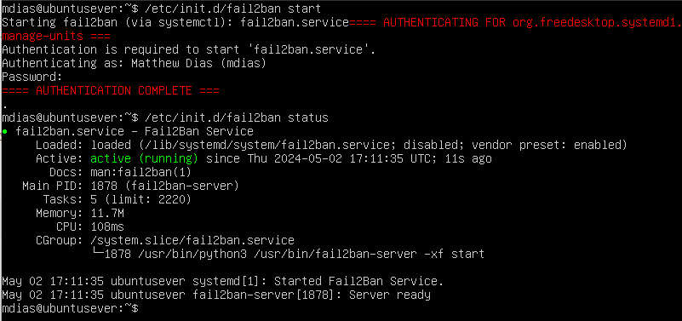

**Ubuntu Install cowsay: 05/02/2024**

What is cowsay? Cowsay is a program that will generates ASCII art of cows or other images along with messages

Installing cowsay is done by running the command sudo apt-get install cowsay. Once this is run you’re all set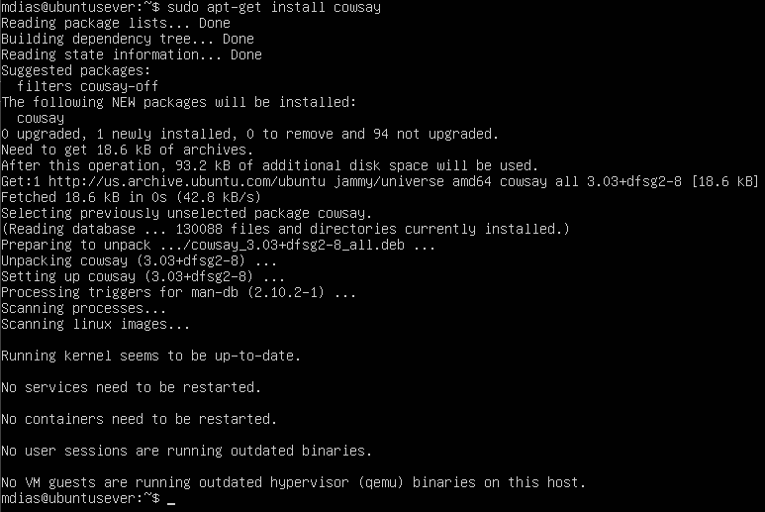

To confirm its installed lets try it out! Run the command cowsay -e @@ Hello. Instead of Hello you can add any message you’d like. This is what the results will look like: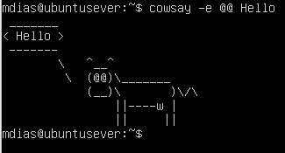

**Ubuntu Install lolcat: 05/02/2024**

What is lolcat? Lolcat runs very similar to the cat command. With lolcat installed it adds rainbow colors into the terminal

Installing lolcat can be done by running the command sudo apt-get install lolcat. It will then ask for you to enter either Y or n. Please enter Y to complete the installation. It will roughly look like the following.

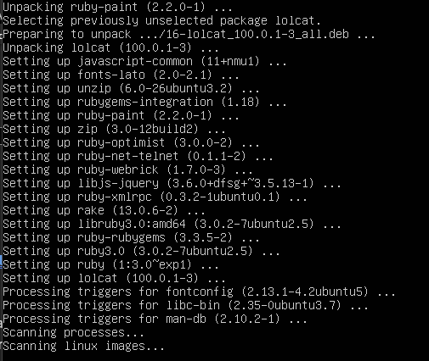

Lets try it out to make sure it installed properly. Type the command lolcat, you can now type freely and type whatever you’d like then hit enter. My results look like this:

CTRL+C will exit lolcat

**CentOS Install Tmux: 05/02/2024**

What is Tmux? Tmux is a terminal multiplexer. This allows you to access and manage multiple terminals at the same time.

Now we will start our installs on our CentOS server. CentOS uses sudo yum install for our installations. We use yum instead of apt-get. Yum stands for “Yellowdog Updater” this is what allows packages to be installed and managed on CentOS. Now, to install tmux we are going to run sudo yum install tmux, you will then be prompted to either type y or n, please type y to finish the installation. All the screenshots below will show you what yours should look like

**

To confirm it downloaded we can once again run tmux -V. See results below

Using tmux is easy! Simply type the command tmux to start the program. This will start the new window. You can use it however you need it to be used. You can see all I did was run ls in the new window. To exit the program you will do CTRL+B first then hit D.

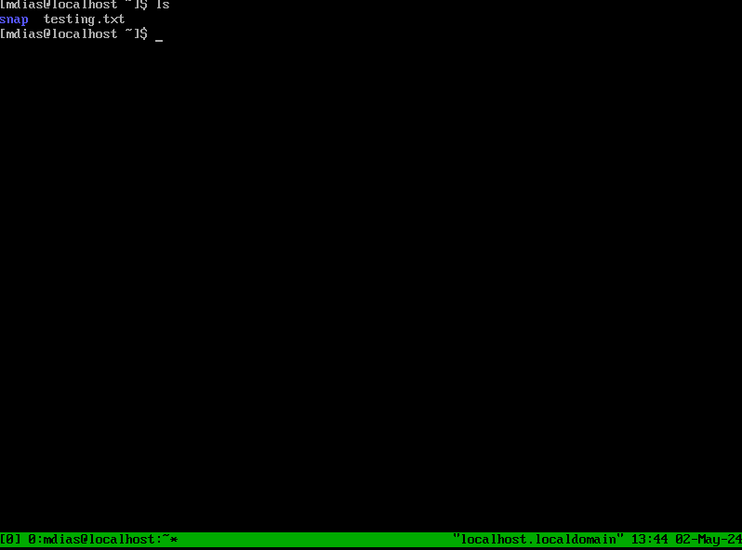

**CentOS Install emacs: 05/02/2024**

What is emacs? Emacs is a text editor that can be used for simply writing text files or going as far as writing code for Python, C, or Java.

Now to install emacs we will use a very similar command to tmux. You will run the command sudo yum install emacs. Once the install begins it will eventually prompt you to type either y or n. Please type y to complete the installation. Your results should be similar to mine: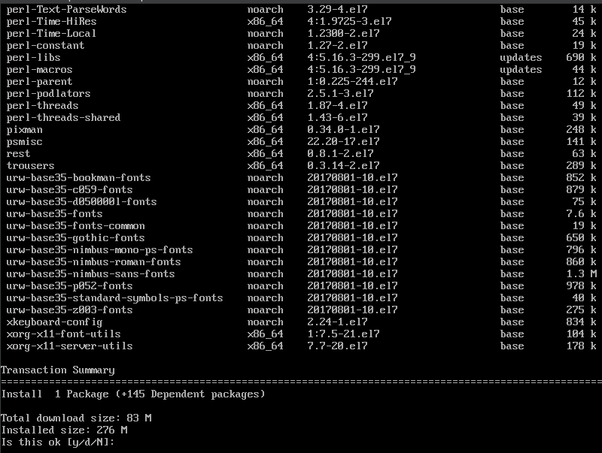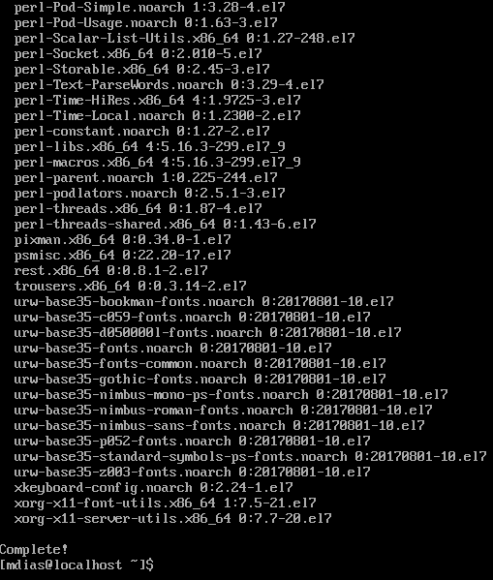

We can verify that it is installed by running emacs -version 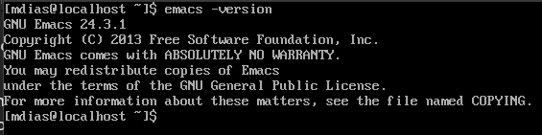

Now using emacs is a learning curve with a lot of options but I’m going to show you how to start it, make a new text file, write in it, save it, and exit the software. First run the command emacs and you’ll get the welcome screen. You will use the arrow keys to make your way down to “Visit New File” and hit enter.

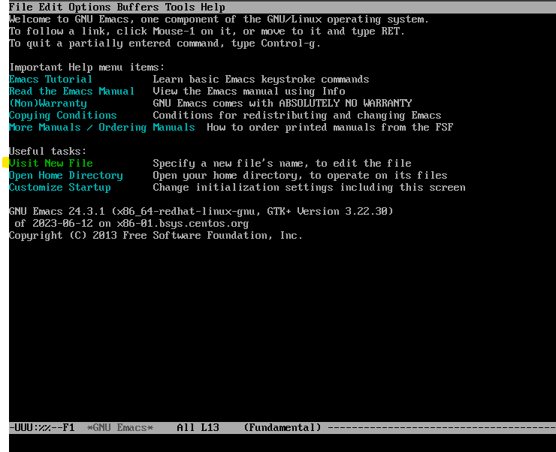

It will be highlighted at the bottom of the screen. Type in a file name, I did text.txt and hit enter. You can now write whatever you’d like to be here. To exit you’re going to do CTRL + X then CTRL+C. You can see the options at the bottom. You can type y to save and exit.

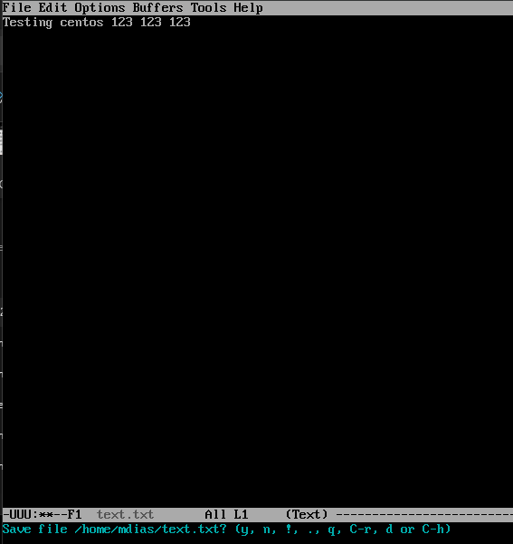

**CentOS Install Fail2Ban: 05/02/2024**

What is Fail2Ban? Fail2Ban monitors your log files to help prevent any malicious brute force attacks on your server

Now we will install Fail2Ban onto our CentOS server. We first need to install EPEL onto our server in order for Fail2Ban to work. To install EPEL we will run the command sudo yum install epel-release. You will be asked to either enter y or n, type in y to continue the install.**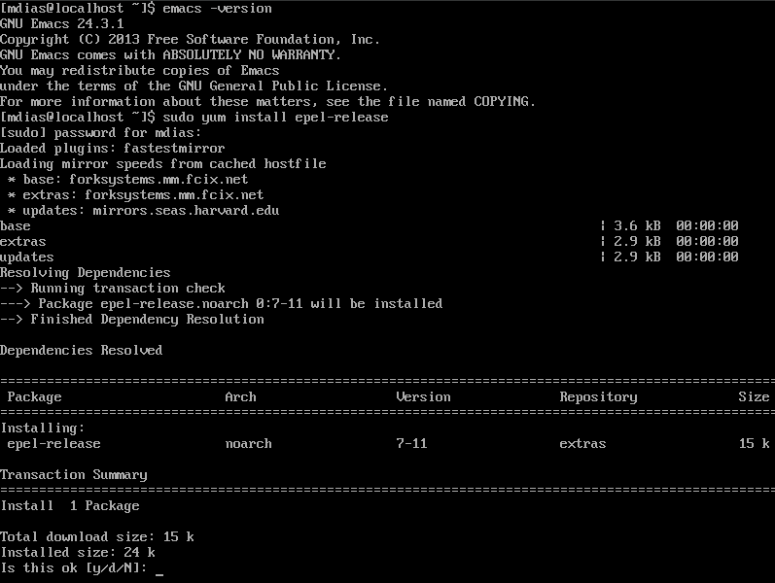

Now we can install Fail2Ban on to the server. You can run the command sudo yum install fail2ban. You will then be prompted with two y or n, type y for both to continue the install.

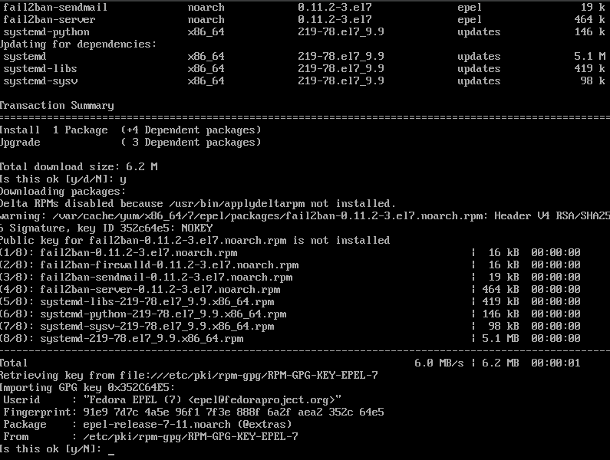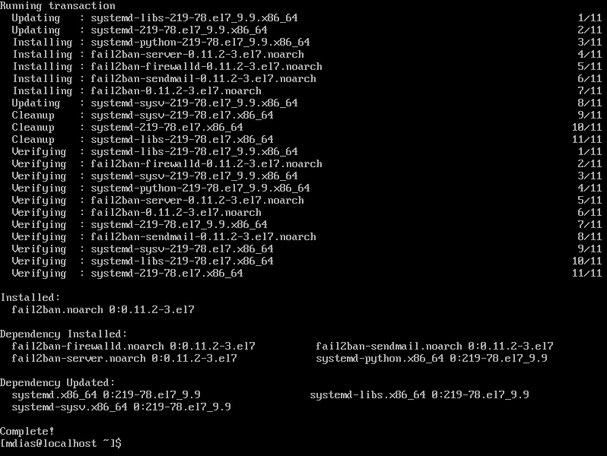

Now we want to enable fail2ban, you can run sudo systemctl enable fail2ban && sudo systemctl start fail2ban. To confirm it is installed and running we can run systemctl status fail2ban:

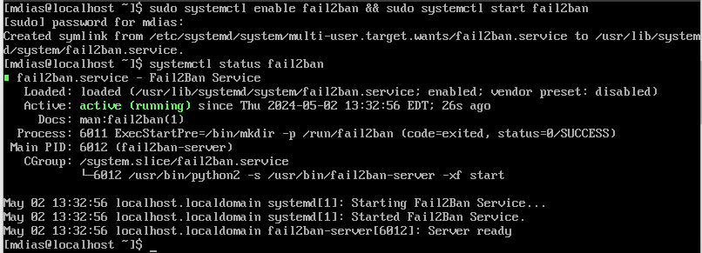

**CentOS Install cowsay: 05/02/2024**

What is cowsay? Cowsay is a program that will generates ASCII art of cows or other images along with messages

Now we will install cowsay to our CentOS server. This is a very simple install and is similar to our Ubuntu install that we did previously. We will run the command sudo yum install cowsay. You will the be asked to enter y or n, please enter y to complete the install.

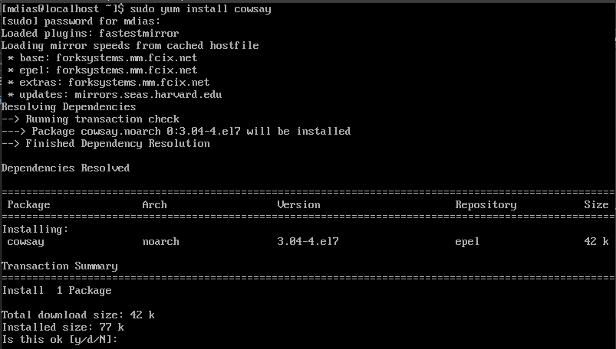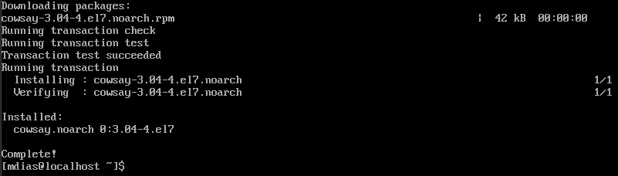

You can now test cowsay by using the command cowsay -e @@ your message. You can make the message whatever you’d like I used “Hello World this is cowsay on CentOS”.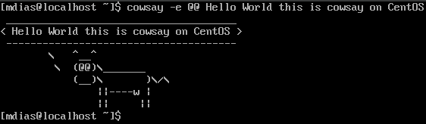

**CentOS Install lolcat: 05/02/2024**

What is lolcat? Lolcat runs very similar to the cat command. With lolcat installed it adds rainbow colors into the terminal ***You can see the link in my references that I used to help assist me and learning how to use snaps and the installation process***

In order to install lolcat onto CentOS we first need to install the package ruby. Lolcat is apart of ruby, so it is required before we can install it properly. We will run the command sudo yum install ruby. You will then be asked to enter y or n, please enter y to complete the install.

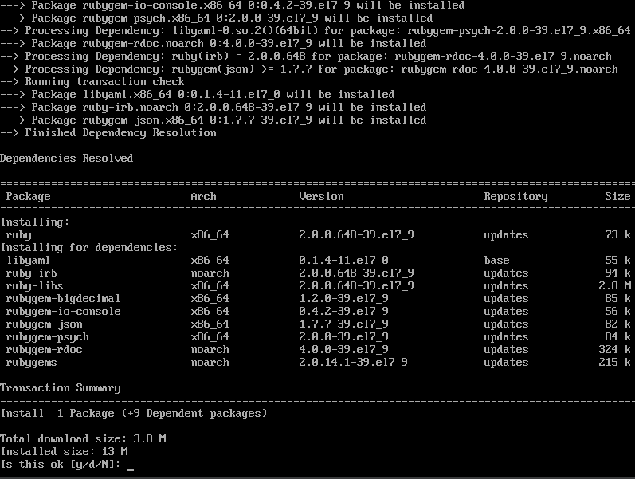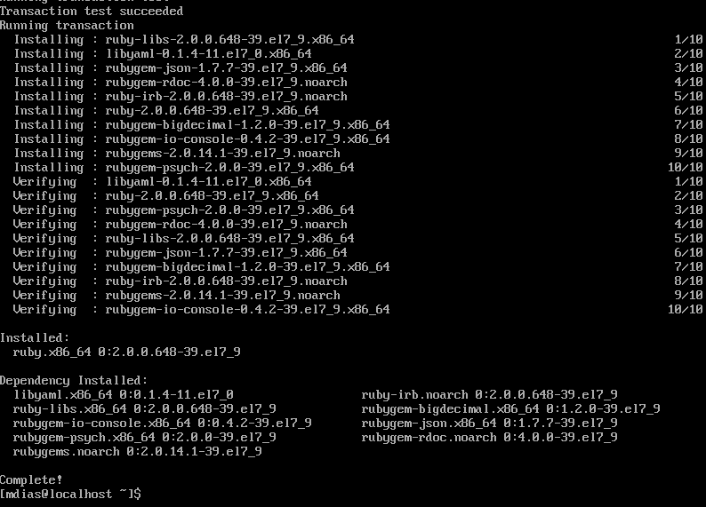

Now we will install lolcat. Unfortunately, lolcat is not as simple as the rest of our installs. We can use something called snapd to install lolcat but we are going to need to install this as well. Snap allows us to install things such as lolcat from online and have them installed and managed easily. We will first run sudo yum install snapd to install snapd. You will be asked to enter y or n, please enter y to complete the install.

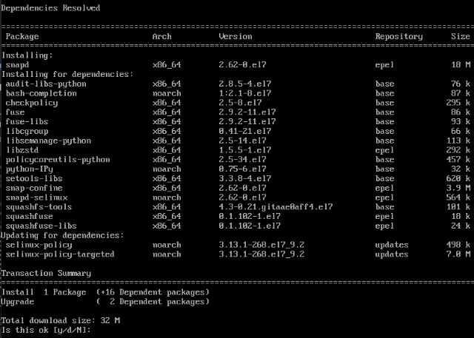

We next need to enable the communication socket by running this command sudo systemctl enable –now snapd.socket.



Finally we will need to make a symbolic link. This link is between /var/lib/snapd/snap and /snap. This is to help us enable classic snap support! We will use the command sudo ln -s /var/lib/snapd/snap /snap. We are now going to install lolcat by running the command sudo snap install lolcat both of these actions are highlighted below!

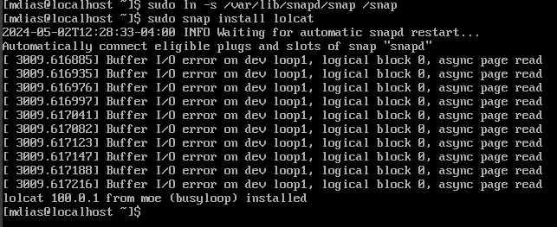

Now we can test lolcat by running the command lolcat and we can write whatever we’d like to test it afterwards. See my example below:

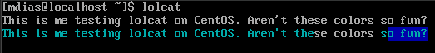

CTRL+C will exit lolcat

**Update Vi > Vim Ubuntu**

What is Vim? Vim is an improved version of Vi with a surplus of new features and improvements.

We will run the command sudo apt-get install vim. Once this is run you will be asked to enter y or n, please enter y to complete the install. This is what it will look like post install once the command is run.

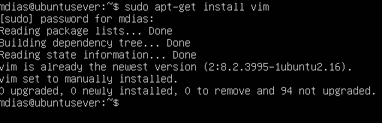

To make sure it installed you can run the command vim. To exit this hit CTRL+C and enter :q

**Update Vi > Vim CentOS**

What is Vim? Vim is an improved version of Vi with a surplus of new features and improvements

In order to install Vim we are going to run the command sudo yum install vim. Once you run this command you will be asked to enter y or n, please enter y to complete to install

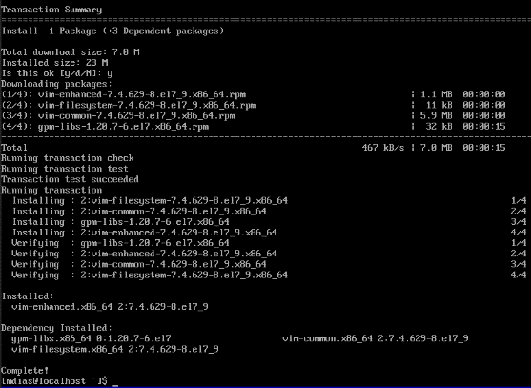

To check if it was properly installed run the command vim. To exit this hit CTRL+C and enter :q

**Overview CentOS**

* Tmux (installed 05/02/2024)
* Emacs (installed 05/02/2024)
* Fail2Ban (installed 05/02/2024)
  + Required Epel (installed 05/02/2024)
  + Properly turned on and documented above (Activated 05/02/2024)
* Cowsay (installed 05/02/2024)
* Lolcat (installed 05/02/2024)
  + Required Ruby (installed 05/02/2024)
  + Required Snaps (installed 05/02/2024)
* Vi > Vim (updated 05/02/2024)

We can now view all of our installed repositories by running yum repolist all

**Overview Ubuntu**

* Tmux (installed 05/02/2024)
* Emacs (installed 05/02/2024)
* Fail2Ban (installed 05/02/2024)
  + Properly turned on and documented above (Activated 05/02/2024)
* Cowsay (installed 05/02/2024)
* Lolcat (installed 05/02/2024)
* Vi > Vim (updated 05/02/2024)

For us to view all of our installed repositories we can use sudo apt install apt-file you can run apt list to see all the listed installs.

**References**

[**https://snapcraft.io/install/lolcat/centos**](https://snapcraft.io/install/lolcat/centos)

[**https://www.baeldung.com/linux/snaps-intro#:~:text=Snapd%3A%20The%20snap%20daemon%3B%20it's,installed%20and%20checked%20for%20updates**](https://www.baeldung.com/linux/snaps-intro#:~:text=Snapd%3A%20The%20snap%20daemon%3B%20it's,installed%20and%20checked%20for%20updates)

[**https://www.csounds.com/manual/html/CommandFlagsCategory.html**](https://www.csounds.com/manual/html/CommandFlagsCategory.html)

[**https://opensource.com/article/21/11/linux-cowsay-command**](https://opensource.com/article/21/11/linux-cowsay-command)

[**https://www.digitalocean.com/community/tutorials/how-to-protect-ssh-with-fail2ban-on-ubuntu-20-04**](https://www.digitalocean.com/community/tutorials/how-to-protect-ssh-with-fail2ban-on-ubuntu-20-04)

[**https://opensource.com/resources/what-emacs**](https://opensource.com/resources/what-emacs)

[**https://www.redhat.com/sysadmin/introduction-tmux-linux**](https://www.redhat.com/sysadmin/introduction-tmux-linux)

[**https://www.oreilly.com/library/view/learning-gnu-emacs/1565921526/ch02s09.html#:~:text=To%20end%20a%20session%20in,writes%20the%20file%2C%20then%20exits**](https://www.oreilly.com/library/view/learning-gnu-emacs/1565921526/ch02s09.html#:~:text=To%20end%20a%20session%20in,writes%20the%20file%2C%20then%20exits)**.**

[**https://www.digitalocean.com/community/tutorials/how-to-use-the-emacs-editor-in-linux**](https://www.digitalocean.com/community/tutorials/how-to-use-the-emacs-editor-in-linux)